


VALLEYCON 30

30TH EDITION
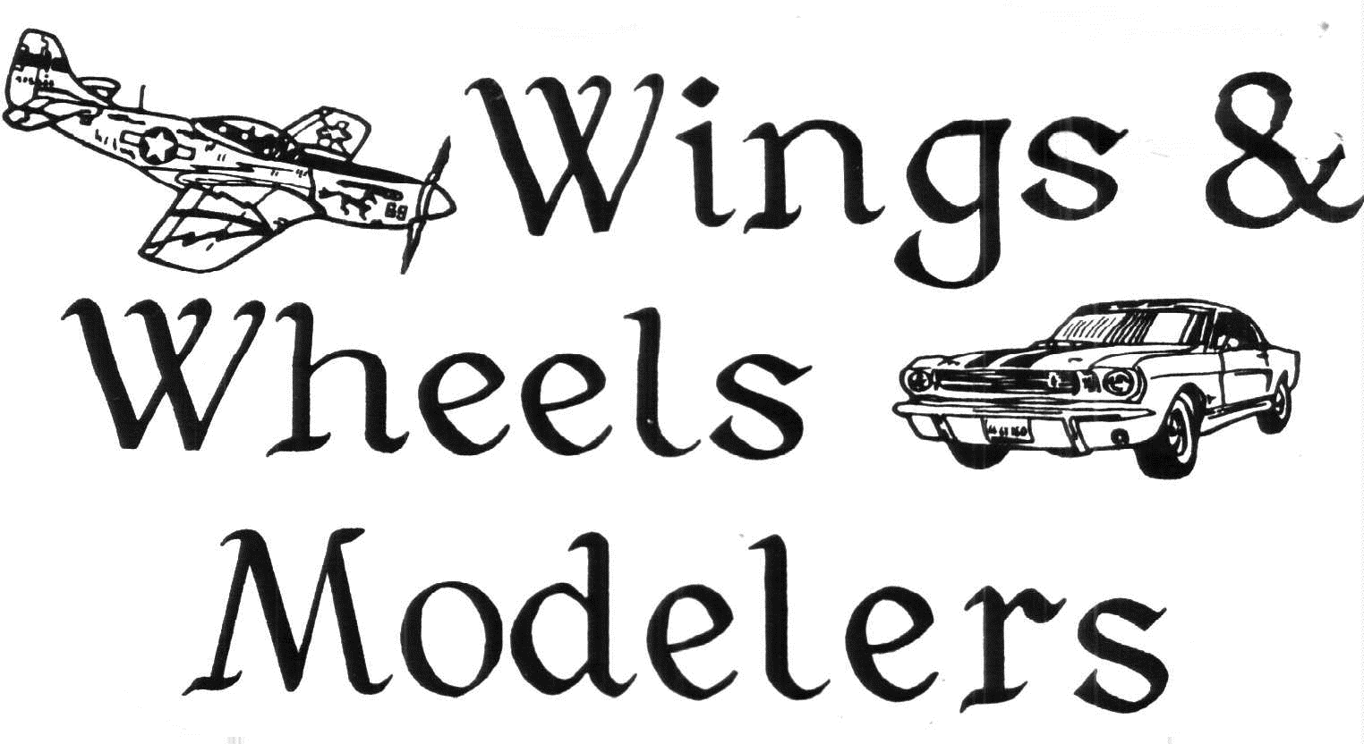

ORLD WAR I
CENTENNIAL

1916 - 2016

OPEN STYLE JUDGING

SUNDAY 10 october 2021
9:00 a.m. to 4:00 p.m.
BEST FIRST RESPONDER/MEDICAL SUBJECT
POLICE, FIRE, RESCUE, AMBULANCE, MEDIC,
DOCTOR, NURSE, HOSPITAL SHIP, ETC.

No admission to the vendor or contest rooms until 9:00 am
Please plan accordingly
KNIGHTS OF COLUMBUS
460 GRANBY ROAD
CHICOPEE, MASS.
REGISTRATION 9:00 A.M. TO NOON
ADULT CONTESTANTS: $5 for first 3 entries, $2 each for the next 5 entries
$15 unlimited number of entries
JUNIOR CONTESTANTS: FREE
GENL. ADMISSION - ADULT: $5 (under 17 FREE with paid Adult admission)

Food and drink available on site
Plenty of free parking
FOR MORE INFORMATION OR VENDOR RESERVATIONS CONTACT
AL LAFLECHE 167 PIPER ROAD WEST SPRINGFIELD MA 01089
(413) 306-1270 E-MAIL: ajlafleche@comcast.net www.wwmodelclub.org

General Rules:

- Each entry must be substantially built and/or painted by the entrant. Die casts, pre-painted and/or promotional models may be displayed, but will not be allowed as entries in the competitive Classes.
- In addition to the requirements stated in the Class description, awards are based on the modeler’s demonstration of basic modeling skills, and where appropriate, reasonable historical or factual accuracy. If your model is of a subject or version not generally known, or requires special knowledge to evaluate, please provide suitable documentation, with your entry, to assist the Judges with their deliberations.
- CAUTION: Contestants who remove their models from the contest tables before 3:30 pm risk having their models not judged for certain awards or photographed for our website. If your travel plans require early departure, please inform the Head Judge no later than 1:00 pm, and we will attempt to accommodate you.
- The Club reserves the right to remove from display or competition any entry which the Club deems offensive or inappropriate, as determined by the Head Judge. In the event a model is removed from competition, the entry fee for that model will be refunded.
- Entries must be made in person, or by proxy, between 9:00 am and noon on the day of the contest.
- No sweeps: only one place award per person per Class. If there are fewer than 3 entrants, we reserve the right to pick which prizes to award. Special Awards if used, are not considered part of a sweep.
- Unless asked not to, Judges may examine models from any reasonable angle; Judges will make every effort to avoid picking up models unless absolutely necessary.
- Models in cases may be displayed; if they are to be judged, the modeler must be willing to remove the case or covering, if requested.
- Entries may be displayed with nameplates, spec. sheets, etc. If the model depicts unusual or atypical aspects, the modeler is encouraged to provide supporting documentation for the Judges.
- Models which have won any place award (including Honorable Mention/Certificate) at a previous WINGS & WHEELS contest are not eligible for competition. Adequate non-competitive display space is available.
- The Club may add, split, combine or delete Classes, as necessary, to ensure a fair competition. These decisions will be made, in most cases, after the close of registration.
- The Club will not be responsible for lost or damaged models, at, coming to or going from the event.
- Award winners must be present, or have a designated person available, to accept awards. Due to the high cost of mailing, no trophies will be mailed to winners without a prepaid, non-refundable fee of $10.00.
- Decisions of the Judges are final.

* Open Judging Award Recognition

To recognize good modelers, and encourage promising ones, WINGS & WHEELS uses the “Open” system to judge entries in certain Classes. The number and level of awards will vary, based on the models entered, and will support the goal that no deserving exhibit should go unrecognized.

For our Show, an exhibit (one or multiple entries from a single competitor) is judged on its own merit of workmanship and modeling skill, not against other exhibits in the Class. Three Judges will decide which entry, within the modeler’s exhibit, is the best piece, and then independently score the selected entry on a scale of 0 to 4, for a maximum score of 12.

11-12 points will earn a Gold Medal, 8-10 a Silver, and 5-7 a Bronze.

Please see www.wwmodelclub.org for a more detailed description of our Open System Competition and judging process.

Class | Open Judging
1.1 | Super Juniors
1.2 | Intermediate Juniors
2.1 | Collections
2.2 | Ships And Boats
2.3 | Space & Science Fiction Machines
2.4 | Misc. Static & Scratchbuilt Models
2.5 | Gundam: Basic
2.6 | Gundam: Advanced
3.1 | Figures – Painting Only
3.2 | Figures – All Aspects
3.3 | Vignettes & Dioramas
4.1 | Small Scale Military Vehicles
4.2 | Tracked Military Vehicles
4.3 | Wheeled & Half tracked Military
4.4 | Artillery Towed & Immobile
 | IPMS Style Judging
5.1 | Showroom Cars/Trucks
5.2 | Street Rods
5.3 | Street Machines
5.4 | Custom Cars/Trucks
5.5 | Competition – closed wheel
5.6 | Competition – open wheel
5.7 | Working Vehicles
6.1 | Single Engine Prop Small Scale
6.2 | Multi Engine Prop Small Scale
6.3 | Jets or Rockets Small Scale
6.4 | Single Engine Prop Lg Scale Axis
6.5 | Single Engine Prop Lg Scale Allied
6.6 | Multi Engine Prop Large Scale
6.7 | Jets or Rockets Large Scale
6.8 | All Rotor Winged Aircraft
6.9 | All Rigged or Multi Winged Aircraft
6.10 | All Civilian Aircraft
Best Wings Best Wheels
Best Figure Best Armor
Best Miscellaneous
BEST FIRST RESPONDER

BEST IN SHOW

